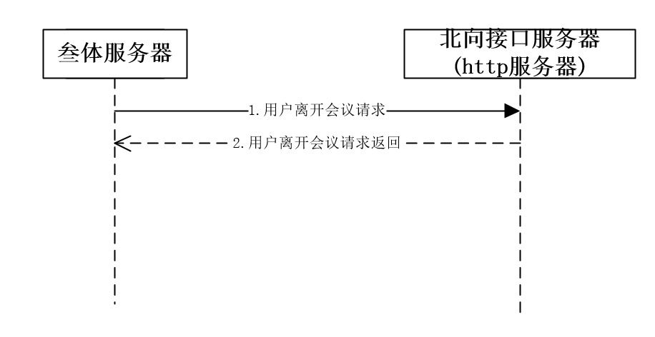

北向接口请求地址配置:

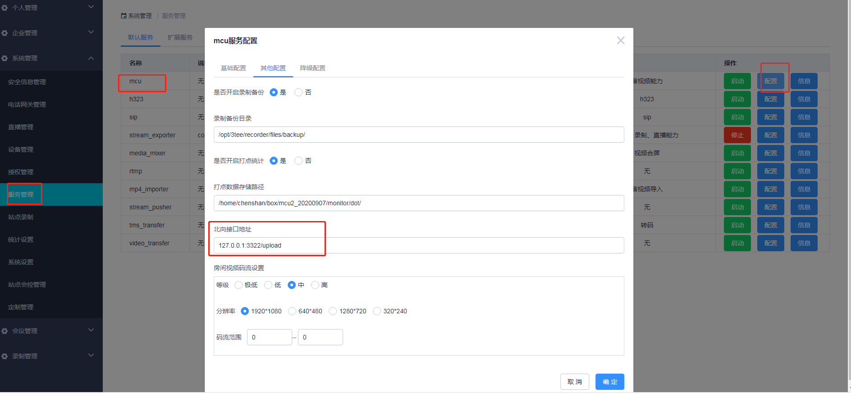

示例:

1.用户离开通知请求:

127.0.0.1:3322/upload?token=77e19b23-529c-41f7-b2a6-349d4539c8ac&room_id=18972290508&event=leave&event_type=normal&user_id=1&endpoint_type=web&user_name=shan

2.停止录制通知请求:

127.0.0.1:3322/upload?token=4f384643-1f71-49c1-88d5-f7def3b382fb&room_id=18972290508&event=stop_record&event_type=success&start_time=1626428261&stop_time=1626428271

注:

具体event类型和参数哦说明请参照北向接口event关系对照表